
Requirements Document
Website Design and Development
January 6, 2014

Rehabilitation Engineering & Assistive Technology Society of North America (RESNA)

Acceptance of Requirements Document:
The Rehabilitation Engineering & Assistive Technology Society of North America (hereinafter, “RESNA”) hereby accepts the features and functionality of the development work defined herein as fully complete and accurate. RESNA further understands that the resulting Statement of Work to be delivered based on the functionality defined herein is predicated upon the level of effort required to produce the functionality as detailed in this Requirements Document. RESNA further understands that any modifications to system features or functionality detailed herein will result in a change to the resulting Statement of Work (SOW) that references this document or may incur a Change Orders to address the additional time and effort required by New Target. After approval of this document and the resulting SOW, Change Orders outlining the scope and cost of requested modifications will be presented by New Target for RESNA's acceptance. Those Change Orders, once accepted by RESNA, will become a part of this Requirements Document. This document along with the Change Orders will define the final Work Product deliverable and supersede all previous proposals or communication.
Acceptance - Please check the appropriate statement.
______ The document is accepted.
______ The document is accepted pending the changes noted.
Please sign and date below
We fully accept the features and functionality described herein and based on our authority and judgment authorize initiation of work to proceed:

RESNA:
Name:
Title:
Date:

Table of Contents

1 Introduction 1
1.1 Purpose of this document 1
1.2 Scope of this document 1
Basic Requirements 2
1.3 Technology 2
1.4 Search Engine Optimization 3
1.5 User roles, Permissions and Workflow 5
2 Content Based Requirements 9
2.1 Taxonomy 9
2.2 Content Types 20
2.3 Menus 58
2.4 Panels Layouts / Landing Pages 59
3 Third Party Integration 61
3.1 Overview 61
3.2 MemberSuite 62
3.3 Member Directory 67
3.4 NewsBriefs 68
3.5 RESNA History Website 69
3.6 Student Design Competition 69
3.7 Prometric Sample Quiz 69
3.8 AT Journal 69
3.9 SOLR Search 70
4 Forms and Form Builder Module 71
4.1 Contact Us 72
4.2 Constant Contact 73
5 Drupal Forum 74
6 Content Migration 75
6.1 301 Redirects 76
6.2 Error pages 77
7 Wireframe / Design Description 78
7.1 Design 78
7.2 Responsive Design 81
8 Accessibility 81
9 Appendix 85
9.1 Sitemaps 85

List of Figures

Figure .1: Panels Layout 60
Figure .2: Architecture Overview 62

Introduction

Purpose of this document
This document is intended to outline RESNA’s requirements for the redesign and consolidation of their existing web properties into a new content management system (CMS) according to the Statement of Work dated April 26, 2013.
RESNA maintains two web properties that address public-facing needs. This document describes how the collection of properties will be redesigned and consolidated for management from within a single content management system (CMS).

Scope of this document
This document defines the presentation, functional, and administration feature set required of the following RESNA Sites:
- http://www.RESNA.org
Excluding:
- http://list.resna.org
The functionality will be moved into Drupal using the forum module.

Basic Requirements

Technology

Overview
CMS: Drupal Version 7
Database: MySQL
Front end: CSS 2 and 3, HTML 4 Transitional, HTML 5, JQuery Library
Media: PNG and JPEG
Video: JW Player (H.264)
Documents: PDF, DOC, DOCX, XLS, XLSX, PPT, PPTX
Search: Solr
Software Stack: LAMP (Linux, Apache, MySQL, PHP)

Browser Support
The websites will be developed for and tested in the following major browsers and versions:
- Chrome (current)
- Firefox (current)
- Internet Explorer (9, 10,11)
- Opera (current)
- Safari (current)
No prior versions or other browsers are supported within this scope of work.

Website Security
The following pages will be inaccessible to anonymous users:
- Manage Account and all account related pages
- Administrator Control Panel

An SSL certificate is currently not required. The login will utilize an http connection. Any donation or transaction based connection will be performed on MemberSuite which utilizes an SSL connection.

WCAG 2.0 Level AA Accessibility
During any step of the development, New Target will ensure that any HTML / CSS output created, maintained, and developed for RESNA will allow persons with disabilities comparable access to information and technology according to the standards in WCAG 2.0 Level AA Accessibility.

Shared Hosting & Maintenance
The website will be hosted at the hosting facility in Ashburn, VA.

RESNA decided to opt-in for the post launch support and maintenance program.

Search Engine Optimization
As part of the site build-out and development of the internal pages, New Target will perform all basic search engine optimization adjustments in order to make the site search engine-friendly.
New Target will advise RESNA on technical steps needed at the server level to ensure that any ranking achieved by the current site, will be maintained. Furthermore, a global redirect for non-www requests to www will be created. For example, requests to http://resna.org/aboutUs will be redirected to http://www.resna.org/aboutUs.

RESNA may prefer to maintain certain existing URLs into the future, in which case New Target will provide mappings of preferred URLs to redirect to new URLs for the content in the new websites.

Google Page Tracking
For Google Page Tracking, the Google Analytics module will be installed.

The code can be adjusted using the configuration in the Google Analytics module. The module allows the tracking of the following:
- Domain, Sub domain, and Multiple top-level domain
- Including or excluding of specific pages
- Role specific tracking
- Number of downloads by file type
- ‘Mailto’ Links
- Outbound Links
- Status Messages
- Internal Search
- Any other custom variables

Since the administrator account is no longer available, New Target will create a new administrator account for RESNA. The administrator account will be using a RESNA.org email address so that the log in credentials can be recovered at any time if necessary.

The new account will be created prior to the launch, and the actual website tracking will continue to run on the old Google Analytics account until the website goes live. This guarantees a clean cut with the new website and statistics.

Search Engine Friendly, Meta Descriptions and Keywords
As part of the site build-out and development of the internal pages, New Target will perform all basic search engine optimization adjustments in order to make the site search engine-friendly. This includes the setup of SEO-friendly URLs, meta description, and keywords to be available for every node. Furthermore, New Target will advise RESNA on technical steps needed at the server level to ensure that any ranking achieved by the current site, will be maintained. Furthermore, a global redirect for non-www requests to www will be created. For example, requests to http://resna.org/about-us will be redirected to http://www.resna.org/about-us.
RESNA may prefer to maintain certain existing URLs into the future, in which case New Target will provide mappings of preferred URLs to redirect to new URLs for the content in the new websites. New Target will create 301 redirects for the migrated content, and create any additional redirects as provided by RESNA in one lump sum. Each page will be migrated into the new system including the old URL attribute, which will then in turn be used to the 301 redirects.

URL Management
Each URL of the CMS can be managed by RESNA. RESNA can decide to have the system automatically create URLs based on their logical position in the information architecture, or RESNA can set the URL depending on the needs. For instance a short URL could be created for an email blast.

User roles, Permissions and Workflow

User Roles
The following roles will be created in Drupal:

Anonymous User
An anonymous user describes one who does not have credentials to log in to the website or a user who may have credentials but is accessing the site prior to logging in. These users have read access to all non-protected parts of the websites. No writing privileges are extended to anonymous users.

Member Types
Certain users belong to groups that need authentication in order to use features such as members-only content. A user’s login will be validated against the MemberSuite database. If the credentials match, the user will be assigned to one of the following types:
- Member
- Certified Member
The membership type can be pulled from MemberSuite using web services. Future member types may be created, and the system will be developed in such a way that member types in MemberSuite can be assigned to roles within Drupal.
Member files are not accessible to non-members, even if they have created a ‘free’ authenticated account. A private file system will be established for publically and privately available files.

Board Member
This role is not defined in MemberSuite, but it will be defined in Drupal to allow the assignment of pages to only Board Members, and no other role. Furthermore, files need to be accessible to only Board Members and no other role.
If a board member is defined in MemberSuite, and it is more beneficial to related to the MemberSuite data, the users will be synchronized on login. The Board members will be assigned to Member role as well.

Product Based Roles
Since users can purchase certain products to be able to access content, roles can be created that match product codes. Depending on if the user purchased the product, the user will then in return on login process is assigned to a product role.

Editor
These users have limited read/write access to one or more content types defined for their functional domains. They will be able to push content forward in the workflow to the Webmaster.

Webmaster
These users have the ability to approve changes made by content editors and publish to the public-facing website. Furthermore, this role has access to content blocks and views. It is essentially a limited site administrator that does not have access to the configuration settings of Drupal and modules.

Site Administrators
These users have comprehensive read/write access to all areas of the websites, including the ability to manage the access rights of other users.
Only users in the role of Content Contributor or greater will have access to media files stored on the website. Only Site Administrators have additional access controls that allow RESNA webmasters to restrict access to certain root level paths based on a user’s functional domain.

Permissions
Permission | Anonymous User | Members | Board Members | Editors | Webmaster | Site  Administrators
View Public Content | X | X | X | X | X | X
View Member Content |  | X | X | X | X | X
View Board Member Content |  |  | X | X | X | X
Edit Content  (all content types) |  |  |  | X | X | X
Publish Content  (all content types) |  |  |  |  | X | X
Delete Content  (all content types) |  |  |  |  |  | X
Manage Menu |  |  |  |  | X | X
Create / Edit Blocks |  |  |  | X | X | X
Create / Edit Views |  |  |  |  |  | X
Configure / Install Modules |  |  |  |  |  | X
Configure Drupal |  |  |  |  |  | X

Workflow Requirements
For all content types, the editor can create and updated nodes. However, the editor role cannot publish the content. The user in the editor role marks the content as ‘Ready for Publishing’. Once the content has been marked as ready for review, the webmaster role will receive an email notifying the user that content is ready for review. The webmaster user can either approve or reject the publishing request, and enter additional comments as needed. Users in the webmaster role can by-pass the workflow.

Revision History
A module (workbench revision) will be included that stores and tracks the history of revisions made to content across the websites. These revisions do not apply to changes made to views or content blocks.

Content Based Requirements

Taxonomy
The following list of taxonomies may not reflect the entire collection of taxonomies to be installed when development begins.

Tag
A tag can be assigned to any content type. It will not be utilized in the first phase of the project as no content has been tagged yet. Once content has been tagged, it can be utilized to cross-reference content, as well as utilizing the data in the faceted search. Additional work that will be necessary to perform these enhancements are not part of the initial scope and will be performed in phase two of the project.

Section
A section is a representation of the main information architecture. Sections are used to assign a page to an area within the website. The section terms are used for creating the URL and the breadcrumbs.

News Category
- Conference News
- Member News
- Certification News
- Continuing Education
- Standards News
The news category will be used in the search facets.

Standards – Keywords
Keywords can be assigned to standards and allow the display of related standards. There will not be a pre-set list of keywords as the content will be developed.

Standards (ANSI and ISO)
This vocabulary has an additional name field which will be used on different views. The name is displayed in brackets after each term in the following listing. Furthermore, the Standards in the first level will be used in the faceted search.
- ANSI/RESNA WC-1:2009
  - American National Standard for Wheelchairs - Volume 1: Requirements and Test Methods for Wheelchairs (including Scooters)
  - Wheelchairs (WCS)
    - Section 1: Determination of static stability
    - Section 5: Determination of dimensions, mass and maneuvering space
    - Section 7: Method of measurement of seating and wheel dimensions
    - Section 8: Requirements and test methods for static, impact and fatigue strengths
    - Section 11: Test dummies
    - Section 13: Determination of coefficient of friction of test surfaces
    - Section 15: Requirements for information disclosure, documentation and labeling
    - Section 16: Resistance to ignition of upholstered parts – Requirements and test methods
    - Section 20: Determination of the performance of stand-up type wheelchairs
    - Section 22: Set-up procedures
    - Section 26: Vocabulary
- ANSI/RESNA WC-2:2009
  - American National Standard for Wheelchairs - Volume 2: Additional Requirements for Wheelchairs (including Scooters) with Electrical Systems
  - Wheelchairs (WCS)
    - Section 2: Determination of dynamic stability of electrically powered wheelchairs
    - Section 3: Determination of effectiveness of brakes
    - Section 4: Energy consumption of electrically powered wheelchairs and scooters for determination of theoretical distance range
    - Section 6: Determination of maximum speed, acceleration and deceleration of electrically powered wheelchairs
    - Section 9: Climatic tests for electrically powered wheelchairs
    - Section 10: Determination of obstacle-climbing ability of electrically powered wheelchairs
    - Section 14: Power and control systems for electrically powered wheelchairs –
Requirements and test methods
    - Section 21: Requirements and test methods for electromagnetic compatibility of electrically powered wheelchairs and motorized scooters
- ANSI/RESNA WC-3:2013
  - American National Standard for Wheelchairs - Volume 3: Wheelchair Seating
  - Wheelchair and Related Seating (WRS)
    - Section 1: Vocabulary, reference axis convention and measures for body, posture and postural support surfaces
    - Section 2: Determination of physical and mechanical characteristics of devices intended to manage tissue integrity – seat cushions
    - Section 3: Postural support devices – Test methods for static, impact and repeated load strength
- ANSI/RESNA WC-4:2012
  - American National Standard for Wheelchairs - Volume 4: Wheelchairs and Transportation
  - Wheelchairs and Transportation (WHAT)
    - Section 18: Wheelchair tiedown and occupant restraint systems for use in motor
vehicles
    - Section 19: Wheelchairs used as seats in motor vehicles
    - Section 20: Wheelchair seating systems for use in motor vehicles
- ANSI/RESNA ASE-2:2012
  - American National Standard for Adaptive Sports Equipment - Volume 2: Adaptive Golf Cars
  - Adaptive Golf Cars (AGC)
    - Section 1: Adaptive Golf Cars Safety and Performance Specifications
- ANSI/RESNA ASE-1: 2007
  - American National Standard for Adaptive Sports Equipment - Volume 1: Winter Sports Equipment
  - Adaptive Sports Equipment (ASE)
    - Section 1 Requirements and Test Methods for Sit-skis, Mono-skis and Bi-skis
- ANSI/RESNA ED-1:2013
  - American National Standard for Evacuation Devices - Volume 1: Emergency Stair Travel Devices Used by Individuals with Disabilities
  - Emergency Stair Travel Devices (ESTD)
    - Section 1: Track-Type, Controlled-Descent, Manual Ascent Devices
- ANSI/RESNA ED-1:2013-T
  - American National Standard for Evacuation Devices - Volume 1: Emergency Stair Travel Devices Used by Individuals with Disabilities Annex A: Test Results Form
  - Emergency Stair Travel Devices (ESTD)
    - Section (none)
- ANSI/RESNA ED-1:2013-I
  - American National Standard for Evacuation Devices - Volume 1: Emergency Stair Travel Devices Used by Individuals with Disabilities Annex B: Inspection Results Form
  - Emergency Stair Travel Devices (ESTD)
    - Section (none)
- Standard Designation (none)
  - Standard Name (none)
  - Ground Surfaces (GS)
    - Section (none)
- Standard Designation (none)
  - Standard Name (none)
  - Inclusive Fitness (IF)
    - Section (none)
- Standard Designation (none)
  - Standard Name (none)
  - Support Surfaces (SS)
    - Section (none)
- Standard Designation (none)
  - Standard Name (none)
  - Vision & Hearing Impairments Committee
    - Section (none)
- Standard Designation (none)
  - Standard Name (none)
  - Cognitive Technologies (CT)
    - Section (none)
- ANSI/RESNA WC-1:1998
  - American National Standard for Wheelchairs - Volume 1: Requirements and Test Methods for Wheelchairs (including Scooters)
  - Wheelchairs (WCS)
    - Section 0: Nomenclature, terms and definitions
    - Section 1: Determination of static stability
    - Section 5: Determination of overall dimensions, mass and turning space
    - Section 7: Method of measurement of seating and wheel dimensions
    - Section 8: Requirements and test methods for static, impact and fatigue strengths
    - Section 11: Test dummies
    - Section 13: Determination of coefficient of friction of test surfaces
    - Section 15: Requirements for information disclosure, documentation and labeling
    - Section 16: Resistance to ignition of upholstered parts – Requirements and test methods
    - Section 20: Determination of the performance of stand-up type wheelchairs
    - Section 22: Set-up procedures
    - Section 93: Maximum overall dimensions
- ANSI/RESNA WC-2:1998
  - American National Standard for Wheelchairs - Volume 2: Additional Requirements for Wheelchairs (including Scooters) with Electrical Systems
  - Wheelchairs (WCS)
    - Section 2: Determination of dynamic stability of electric wheelchairs
    - Section 3: Test methods and requirements for the effectiveness of brakes
    - Section 4: Determination of energy consumption of electric wheelchairs and scooters – Theoretical range
    - Section 6: Determination of maximum speed, acceleration and retardation of electric wheelchairs
    - Section 9: Climatic tests for electric wheelchairs – Requirements and test methods
    - Section 10: Determination of obstacle-climbing ability of electric wheelchairs
    - Section 14: Power and control systems for electric wheelchairs
    - Section 21: Requirements and test methods for electromagnetic compatibility
______________________________________________
ISO
- ISO 7176
  - International Standard ISO 7176
  - Technical Committee ISO/TC 173, Technical systems and aids for disabled or handicapped persons, Subcommittee SC 1, Wheelchairs
    - Part 1: Determination of static stability (WCS addresses parallel work)
    - Part 2: Determination of dynamic stability of electric wheelchairs (WCS addresses parallel work)
    - Part 3: Determination of effectiveness of brakes (WCS addresses parallel work)
    - Part 4: Energy consumption of electric wheelchairs and scooters for determination of theoretical distance range (WCS addresses parallel work)
    - Part 5: Determination of overall dimensions, mass and turning space (WCS addresses parallel work)
    - Part 6: Determination of maximum speed, acceleration and deceleration of electric wheelchairs (WCS addresses parallel work)
    - Part 7: Measurement of seating and wheel dimensions (WCS and WRS address parallel work)
    - Part 8: Requirements and test methods for static, impact and fatigue strengths (WCS addresses parallel work)
    - Part 9: Climatic tests for electric wheelchairs (WCS addresses parallel work)
    - Part 10: Determination of obstacle-climbing ability of electric wheelchairs (WCS addresses parallel work)
    - Part 11: Test dummies (WCS addresses parallel work)
    - Part 13: Determination of coefficient of friction of test surfaces (WCS addresses parallel work)
    - Part 14: Power and controls systems for electric wheelchairs — Requirements and test methods (WCS addresses parallel work)
    - Part 15: Requirements for information disclosure, documentation and labelling (WCS and WHAT address parallel work)
    - Part 16: Resistance to ignition of upholstered parts — Requirements and test methods (WCS and WRS address parallel work)
    - Part 19: Wheeled mobility devices for use as seats in motor vehicles (WHAT addresses parallel work)
    - Part 21: Requirements and test methods for electromagnetic compatibility of electrically powered wheelchairs and scooters, and battery chargers (WCS addresses parallel work)
    - Part 22: Set-up procedures (WCS addresses parallel work)
    - Part 26: Vocabulary (WCS, WRS, and WHAT address parallel work)
    - Part 28: Requirements and test methods for stair-climbing devices (WCS addresses parallel work)
- ISO 10542
  - Technical systems and aids for disabled or handicapped persons — Wheelchair tiedown and occupant-restraint systems
  - Technical Committee ISO/TC 173, Assistive products for persons with disability, Subcommittee SC 1, Wheelchairs (WHAT addresses parallel work)
    - Part 1: Requirements and test methods for all systems
    - Part 2: Four-point strap-type tiedown systems
    - Part 3: Docking-type tiedown systems
    - Part 4: Clamp-type tiedown systems
    - Part 5: Systems for specific wheelchairs
- ISO 10865
  - Wheelchair containment and occupant retention systems for accessible transport vehicles designed for use by both sitting and standing passengers
  - Technical Committee ISO/TC 173, Assistive products for persons with disability, Subcommittee SC 1, Wheelchairs (WHAT addresses parallel work)
    - Part 1: Systems for rearward-facing wheelchair-seated passengers
- ISO 16840
  - Wheelchair seating
  - Technical Committee ISO/TC 173, Assistive products for persons with disability, Subcommittee SC 1, Wheelchairs
    - Part 1: Vocabulary, reference axis convention and measures for body segments, posture and postural support surfaces (WRS addresses parallel work)
    - Part 2: Determination of physical and mechanical characteristics of devices intended to manage tissue integrity — Seat cushions (WRS addresses parallel work)
    - Part 3: Determination of static, impact and repetitive load strengths for postural support devices (WRS addresses parallel work)
    - Part 4: Seating systems for use in motor vehicles (WHAT addresses parallel work)

Event Category
- RESNA event (always shows first above a partner event)
- CEU event
- Webinars
- Courses
- Conferences
- Partner events
The event category will be used in the search facets.

Continuing Education Category
- AAC
- Computer Access
- Job Accommodations
- Seating
- Special Education
- AT Fundamentals
The continuing education category will be used in the search facets.

Testimonial Type
- Textual
- Story
- Video

Testimonial
- Membership
- Certification
- Professional Development
- Knowledge Center
- Conference

Content Types
Each content type has the following attributes:
- Section
  - This will define the logical placement of the content within the site. It will define the URL path settings if not specifically specified in the section below.
  - Initially, the section is based on the main menu.
- Meta Keywords and Meta Description
- Tag [allows free tagging of content]

For all views, caching will be enabled for 5 minutes to significantly improve the overall performance of the website. This means that the page content (updates, newly created pages) will not show up for up to 5 minutes on views after changes have been made. Content editor and content contributors need to be made aware of this feature.

Basic Page

At a Glance
A basic page is used for static content, such as an 'About us' page.

Content Fields
- Title [text field*]
- Summary [summary field]
- Body [body field*]

Block View
The basic content type is not used in any block view.

List Views (Grid / List)
The basic content type is not used in any list view.

Landing Page View
The basic content type does not utilize a landing page view, but follows the main template which provides a left sidebar (25%) and main content area (75%).

Publishing workflow
The editor user role can create basic pages, but has to submit the content for publishing to the webmaster that can publish or reject the publishing request along with comments. The webmaster and site administrator can by-pass the publishing workflow at any time.

RSS feed
The basic content type does not utilize any RSS feed.

Navigation Flow, URL Structure and Menu Positions
Any basic page can be part of the navigation. Depending on which section the page is assigned to, the URL structure will be created automatically or RESNA can choose to define the URL.

Access / Permissions
Anonymous user can access the content. RESNA can define on a page to page basis which role will have access to this content type using node access.

References to Wireframes
http://resna.newtarget.net/about

Other Notes

Conference

At a Glance
This content type is used for each conference. Besides displaying a conference image and content, It allows to reference existing content at the bottom of the page such as ‘Program’, ‘Registration’, or ‘Venue’.

Content Fields
- Title [text field*]
- Summary [summary field*]
- Body [body field*]
- Image [image upload, x by y px]
- Conference News [taxonomy pick list]
- Program [node reference]
- Workshops [node reference]
- Registration [node reference]
- Venue [node reference]
- Call for Papers [node reference]
- Conference Webcast [node reference]
- Conference Year [text field*]

Block View
Only used on the landing page and not on any pages of the website.

List Views (Grid / List)
Only used on the landing page and not on any pages of the website.

Landing Page View
The representation below does not reflect the left side bar and only shows the main content of the conference. A left sidebar will be part of the conference template.
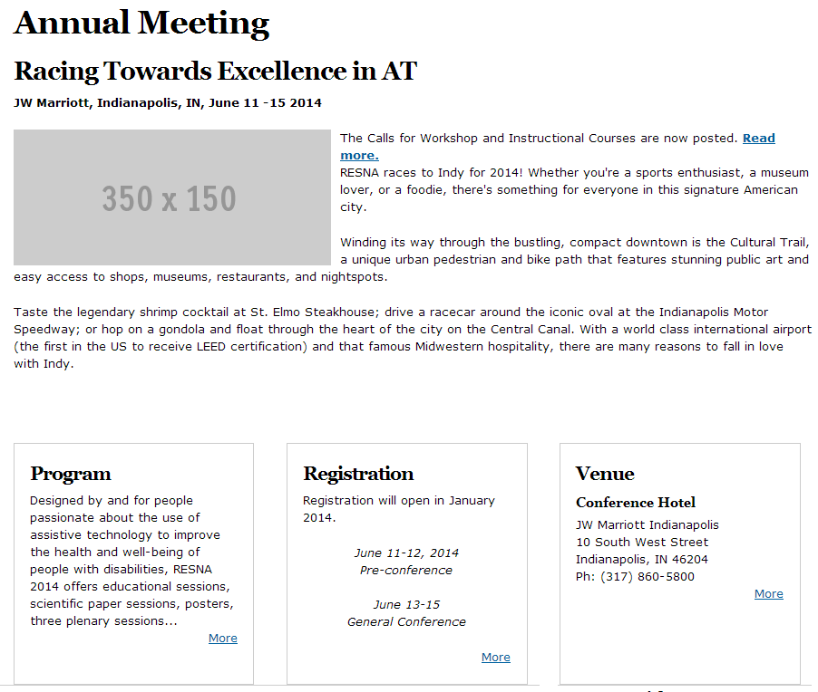

The main content area shows the title (Annual Meeting) along with the body of the node which includes the secondary headers, the image, and the main content. Below the main content, content blocks are visible to display relevant information through a node reference. For instance, the program, registration, and venue reference show the summary of the actual node (which are all basic pages). In addition, other content blocks can be pulled out for

Conference News [term reference]

Will show the latest three news items depending on what taxonomy term was selected. For instance, for the upcoming annual meeting, news items could be tagged as ‘Conference 2014’.
- Workshops
- Call for Papers
- Conference Webcast
For visual appealing, New Target recommends to display content in blocks of three to avoid empty spaces on this landing page.

Publishing workflow
The editor user role can create a new conference node, but has to submit the content for publishing to the webmaster that can either approve or reject the publishing request with additional notes. The webmaster and site administrator can by-pass the publishing workflow.

RSS feed
Not part of any RSS feed.

Navigation Flow, URL Structure and Menu Positions
/events/annual-conference/{title}

Access / Permissions
Anonymous user can access the content. There is no need to restrict this content type on a node to node basis.

References to Wireframes
http://resna.newtarget.net/news-events/annual-meeting

Other Notes
N/A.

Slide Show

At a Glance
This content type is used for slide shows throughout the website. Slideshow can be used on different landing pages.

Content Fields
- Headline [text field*]
- Introduction/Summary [text field*]
- Link URL [node reference, but the user should also be able to use external links]
- Image Upload [image upload*, x by y px]
- Weight [for ordering, if weight is the same, the date will be the deciding factor]

Block View
The following screen shot represent the block view as it is used on the homepage.


The headline will be used as the title; the introduction/summary field will be used as the caption. If the link URL is filled out in the node, the entire image will link to the corresponding page. The weight will be used for ordering the slide show items. If the weight is the same, the date will be the deciding factor (desc).

List Views (Grid / List)
Not needed as it is only used as a feature on the homepage and panels.

Landing Page View
This slide show is not part of a landing page view.

Publishing workflow
The editor user role can upload and create the slide show, but has to submit the content for publishing to the webmaster. The webmaster and site administrator can by-pass the publishing workflow.

RSS feed
No RSS feed will be created for this content type.

Navigation Flow, URL Structure and Menu Positions
This content type will not be part of the Navigation and does not require any URL structure. Furthermore, this content type should not show up in search results.

Access / Permissions
Anonymous user can access the content through the view, but not individual nodes.
Webmaster and above can edit / upload new slides.

References to Wireframes
http://resna.newtarget.net/

Other Notes
The slide show will be excluded from the search, and this content type cannot be added to the menu.

FAQ

At a Glance
FAQ items can be listed on any given page using block views with selected categories.

Content Fields

An FAQ content type consists of the following items:
- Question [text field*]
- Answer [text field*]
- Section [single select; vocabulary Section]
- FAQ category [multi-select; vocabulary FAQ Category]
- Weight (for ordering)

Block View
A block view for each category will be created allowing DAR to show FAQs in different sections of the website with questions and answers applicable to that section. The reference can be achieved by either the section term or the FAQ category.
If used in a block view, only the questions will be visible. On click, the user will be redirected to the corresponding anchor tag on the list view within the category the FAQ is in.

List Views (Grid / List)
The list view will show the categories listed at the top of the page. Each categegory links to an anchor tag to the corresponding section. Each category lists all questions on top and all answers are linked through an anchor tag (questions is linked to the anchor tag). The following layout will be used:

{Category 1}
{Category 2}
{Category 3}
Etc.
.
.
.
{Category 1}
{Question 1}
{Question 2}
{Question 3}

{Question 1}
{Answer 1}

{Question 2}
{Answer 2}

{Question 3}
{Answer 3}
.
.
.
{Category 2}
Etc.

The view takes the category as an input meaning that each category can be listed by itself.

Landing Page View
N/A.

Publishing workflow
The editor user role can create this content, but has to submit the content for publishing to the webmaster that can either approve or reject the content along with comments. The webmaster and site administrator can by-pass the publishing workflow.

RSS feed
No RSS feed will be created for this content type.

Navigation Flow, URL Structure and Menu Positions
This content type will not be part of the Navigation and does not require any URL structure. This content type will show up in search results.

Access / Permissions
Anonymous user can access the content through the views and blocks, but not individual nodes.
Webmaster and above can edit / upload new FAQs.

References to Wireframes
N/A.

Other Notes
N/A.

Continuing Education (Courses / Webinars)

At a Glance
This content type will be used for the continuing education section under professional development. With the help of categories, Webinars and Courses can be created with this content type.

Content Fields
- Title [text field*]
- Summary [summary field*]
- Body [body field*]
- About the Course [full text field]
- Start and End Date [date and time picker]
- Start and End Time [date and time picker]
- Registration Deadline [date picker]
- Location [grouping]
  - Location Title [text field]
  - Street [text field]
  - City [text field]
  - State [select field]
  - Zip [text field]
- Member Cost [text field]
- Non-Member Cost [text field]
- Learning Outcomes [full text field]
- CEUs [text field]
- Course Brochure [File Upload, single file uploaded]
- Syllabus [File Upload, single file upload]
- Course Format [File Upload, multiple file upload]
- FAQ [FAQ category; multi-select]
- Course Sections [full text field]
- Instructor [node reference, multi select]
- Member and Non Member Registration Links?
- Category [category, Webinar or Course]
- Video [YouTube Reference] / JW Player / Vimeo
- Product Code [multiple product codes, comma separated list]
  - Only if a user purchased a specific product, then they will be able to see this video

Block View

The image above shows a typical block view. It shows a global title along with the next four upcoming continuing education nodes. Each node in the view shows the date along with the title which links to the actual node.
The ‘More Upcoming Continuing Education’ link redirects the user to the list view (see below).

List Views (Grid / List)

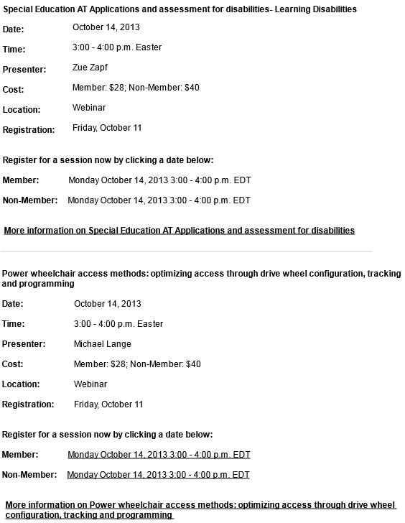

On top of the list view, the different categories of the Continiung Education vocabulary (AAC, Computer Access, Job Accommodations, Seating, Special Education, AT Fundamentals, etc.) links will be displayed. Once the user clicks on one of the links, the page will reload with a list of items assigned to the selected catgegory.
The listing will show ten nodes and the page will be concluded with pagination to access items in the future. The example above shows each item with a title (links to the actual node), the date, time, presenter / instructor, cost, location, registration deadline, member and non-member registration links, as well as a link to the node which will be created as ‘More Information on {title}’.
If there are multiple instructures (i.e. presenters), then a comma separated list of instructors will be listed (each with their first and last name).

Landing Page View
The image below shows the actual node as a user would be redirected to it through the search or the block / list views above.
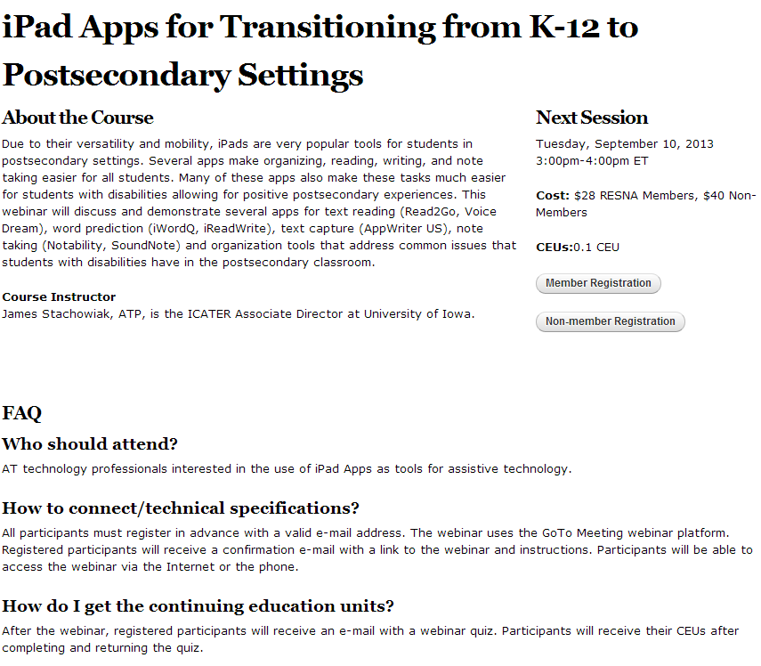
The page will start of with the main title, followed by the actual body (main content). On the right hand side, detailed information on the next session such as date, time, costs (member and non-member), CEUs, and registration links (member and non-member) will be displayed.
If a video is available, it will be displayed between the course instructor and the FAQs.
At the bottom of the page, FAQs will be displayed depending on which FAQ categories are matching as the FAQ categories will be shared between this content type and the the FAQ content type.

Publishing workflow
The editor user role can create this content, but has to submit the content for publishing to the webmaster that can either approve or reject the content along with comments. The webmaster and site administrator can by-pass the publishing workflow.

RSS feed

An RSS feed for this content type will be created. The latest 25 items are listed.

Navigation Flow, URL Structure and Menu Positions

The URL will for this content type will be created as follows:
professional-development/continuing-education/{category webinar or course}/title

Access / Permissions
Anonymous user can access the content.
Webmaster and above can edit / upload new content.

References to Wireframes
http://resna.newtarget.net/professional-development/webinars/ipad-apps-transitioning-k-12-postsecondary-settings

Other Notes
The content type is used in two different locations in the main menu and therefore two views need to be created to display either Webinar or Course. The views need to be placed under Professional Development -> Webinar and Professional Development -> Continuing Education -> Course

Instructor / Presenter

At a Glance
An instructor will be referenced from a Webinar or Course (content type Continuing Education). An instructor / presenter can be re-used on different Webinars and Courses.

Content Fields
- Name [text field*]
- Title Prefix [text field]
- Title Suffix [text field]
- Summary [summary field*]
- Body [body field*]
- Image Upload [image upload, 90 by 100 px]

If possible and beneficial, the instructor will be pulled from the MemberSuite database using an ID reference.

Block View
Block view within landing page of Courses:
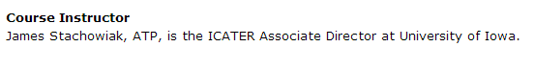
The full name along with prefix or suffix will be displayed. On the landing page view, the summary field will be displayed. On click of the name, the user will be redirected to the actual node. If an image is available for the instructor, it will be displayed to the left of the name.

List Views (Grid / List)
Only used on the course template and not on any pages of the website.

Landing Page View
Only used on the course template and not on any pages of the website.

Publishing workflow
The editor user role can create new instructors, but has to submit the content for publishing to the webmaster that can either approve or reject the content along with comments.. The webmaster and site administrator can by-pass the publishing workflow.

RSS feed
Not part of any RSS feed.

Navigation Flow, URL Structure and Menu Positions
Only used on the course template and not on any pages of the website.

Access / Permissions
Anonymous user can access the content.
Webmaster and above can edit / upload new slides.

References to Wireframes
http://resna.newtarget.net/professional-development/webinars/ipad-apps-transitioning-k-12-postsecondary-settings

Other Notes
The content type will not appear in the search.

Standards

At a Glance
Adding a new item in this content type will create a node in the standards section. A standard will be used on the standard landing pages (panels).

Content Fields
- Standard Number [text field*]
- Standard Title [text field*]
- Standard Designation [full text field]
- Standard Development Committee [node reference to committee content type]
- Standard Category [single select; vocabulary Standards (ANSI and ISO) picker]
- Book of Standards Volume [text field]
- URL grouping
  - Link description, URL, image, price
  - [multiple, Link Description, URL, additional image upload [URL used to link image]]
  - Standards Purchase Link for PDF [URL]
  - Standards Purchase Link Print [URL including text to display]
  - Standards Purchase Link Redline [URL including text to display]
- Abstract [full text field]
- Scope [full text field]
- Reference Documents [multiple file upload including description, PDF, DOC, DOCX, max 2MB]
- Keywords [multi-select, vocabulary Standards - Keywords]
- ICS Codes [full text field]

Block View
A block view not be created for this content type.

List Views (Grid / List)
The list view will list the full list of the vocabulary Standards (ANSI and ISO). In brackets, each term will show how many items are assigned to that specific term. Top level categories will include all items of the sub category.
- AGC (Name: Adaptive Golf Cars) (2)
  - ANSI (2)
    - ASE-1:2007 (2)
- ASE (Name: Adaptive Sports Equipment) (3)
  - ANSI (3)
    - ASE-1:2007 (3)
- CT (Name: Cognitive Technologies) (1)
- ESTD (Name: Emergency Stair Travel Devices used by Individual with Disabilities) (1)
  - ED-1:2013 (1)
  - ED-1:2013-I (3)
  - ED-2013-T (2)

On click, the user gets a listing of the nodes within that term:
{Standard Number 1} – {Standard Title 1}
{Standard Abstract 1}

{Standard Number 2} – {Standard Title 2}
{Standard Abstract 2}

{Standard Number 3} – {Standard Title 3}
{Standard Abstract 3}
.
.
.
Etc.

On click on the title, the user will be redirected to the landing page view.

Landing Page View
The landing page view shows the actual full content of the node as seen in the reference below:
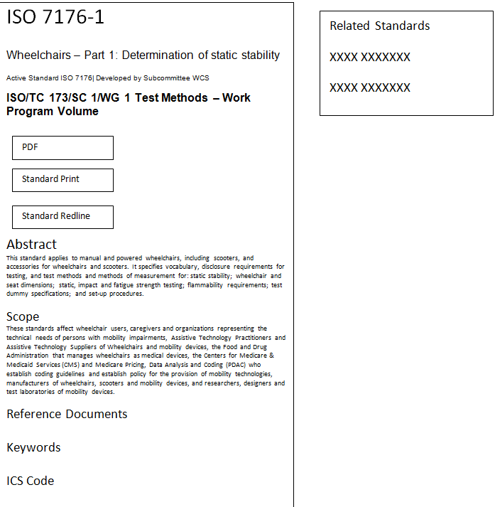

Related Standards are based on Standards keywords and Standards Category.
- Show up to 5 related items.
- Related content to show up when there are not related standards.

Publishing workflow
The editor user role can create standards, but has to submit the content for publishing to the webmaster that can publish or reject the publishing request along with comments. The webmaster and site administrator can by-pass the publishing workflow at any time.

RSS feed

No RSS feed will be created for this content type.

Navigation Flow, URL Structure and Menu Positions
at-standards/{category}/title

Access / Permissions
Anonymous user can access the content.
Webmaster and above can edit / upload standards.

References to Wireframes
N/A.

Other Notes
N/A.

News

At a Glance
Adding a new item in this content type will create a node in the news section. It will automatically be added to any content block or conference (if the same taxonomy terms were used).

Content Fields
- Title [text field*]
- Summary [summary field]
- Body [body field*]
- Date [date picker]
- Category [Vocabulary News]

Block View



List Views (Grid / List)
Once the user clicks on ‘More News’ or get on the news directly via the menu link the following list view will be presented to the user:
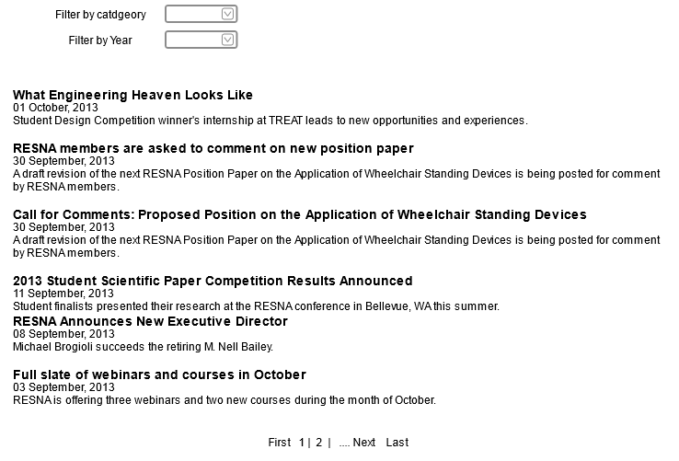
Despite the example above, the view will show ten items per page, and the summary field will be used to display the content. If there is no summary available, the first 200 characters will be pulled from the body field.
On top of the listing, two filters will be presented to the user:
- Filter by News Category
- Filter by Year
By default, the view will only return information from the current year.

Landing Page View
The landing page view shows the full content of the node. In addition, the date and category will be displayed under the title:

{Title}
{Date} {Category}

{Body}

Publishing workflow
The editor user role can upload and create the slide show, but has to submit the content for publishing to the webmaster. The webmaster and site administrator can by-pass the publishing workflow.

RSS feed

An RSS feed for this content type should be created. The latest 15 items should be listed.

Navigation Flow, URL Structure and Menu Positions
news/newsroom/{category}/title

Access / Permissions
Anonymous user can access the content.
Webmaster and above can edit / upload new slides.

References to Wireframes
N/A.

Other Notes
N/A.

Events

At a Glance
Events will be featured throughout the website and different categories are available. RESNA events always have priority over other events and will always be displayed (despite the category selection the user may have chosen). This applies to list and grid views and any content block.

Content Fields
- Title [text field*]
- Summary [summary field*]
- Body [body field*]
- Start Date [date picker]
- End Date [date picker]
- Category [Vocabulary Events Category]

Block View

The block view shows the next 4 upcoming events ordered by the ascending order from the current date. The listing will show the date and the title (which will link to the the actual node).
The ‘More Events’ link will redirect the user to the List View (see below).

If there are items tagged as RESNA event or Partner event and have the same data, then the RESNA event should always show first.

The content block can be utilized on other sections of the website filtered by the event category to only show events of interest for the corresponding section.

List Views (Grid / List)

The list view will be grouped by year and month and will show 20 upcoming events in ascending order. At the bottom pagination will be used to navigate through the result set.
At the top of the page, the user can switch from list view over to grid view which allows the user to see the content in a calendar form. Furthermore, a filter based on the Events Category can be used to filter the list or grid (calendar) view. Each category will be displayed with an abbreviation which a legend under the calendar will explain. The ‘RESNA event’ will not be listed in the filter as RESNA events will always be visible in the list or grid view independent from the user selection.
Above the pagination / under the calendar view, a link to submitting an event will be placed. The link is only visible to members.

Landing Page View
The landing page will use the following layout:

{Title}
{Start Date} – {End Date} {Category}
{Body}

Publishing workflow
Members, editors, webmaster, and site administrator are able to create events. Members and editors cannot publish events as it has to be approved by either webmaster or administrator.
A member cannot choose the event category. During the approval process, RESNA has to select the category.

RSS feed

An RSS feed for this content type will be created. The latest 25 items will be listed.

Navigation Flow, URL Structure and Menu Positions
The events will be placed under the News and Events menu item. The URL pattern should follow the pattern of the menu which should be:
/news-events/events/

Access / Permissions
Anonymous user can access the content through the view and content blocks. The individual nodes are searchable.
Members can create new events, but not manage them.

References to Wireframes
N/A.

Other Notes
N/A.

Sponsor

At a Glance
A sponsor will be shown on the conference pages on the left hand site. On page refresh, a random sponsor will be displayed.

Content Fields
- Name [text field*]
- Body [body field*]
- Image Upload [image upload*]
- Conference Year [text field, can be comma separate list]

Block View
The block view shows one random sponsor image at a time. There is no functionality behind the sponsor content type other than displaying the actual image.

The block view will be utilized to show the content on the left hand side throughout all pages of the conferences.

List Views (Grid / List)
A 3x3 grid view will be used to show the nodes of this content type. It will simply list the images and name (under the image) of all sponsors within the current year. The view should be able to handle the year as an argument so that future and past sponsor listings can be created.

Landing Page View
N/A.

Publishing workflow
Content editors can create the nodes of this content type, but are never able to publish the content. Editors will mark the content as ready to review through which an email will be triggered to the webmaster. The webmaster (administrator) can publish the content or decline the publication with a comment. The webmaster and administrator can always by-pass the publishing workflow.

RSS feed
Not part of any RSS feed.

Navigation Flow, URL Structure and Menu Positions
This content type will not be part of the Navigation and does not require any URL structure. Furthermore, this content type should not show up in search results.

Access / Permissions
Anonymous user can access the content through the view, but not individual nodes.
Webmaster and above can edit / upload new sponsors.

References to Wireframes
N/A.

Other Notes
This feature may be moved into OpenX as the tracking of the data and number of page impressions can be accomplished within the banner ad management software.
However, list views will no longer be dynamic with OpenX and the content has to be placed on a static page (e.g. a basic page).
OpenX is available for a monthly fee of $25.

AT Journal Quiz

At a Glance
This content type will be used to create different Quizzes along with PDF versions of an AT Journal Article and Quiz.

Content Fields
- Title [text field*]
- Summary [summary field]
- Body [body field]
- Author [text box]
- Journal Upload [file upload, PDF, DOC, DOCX]
- Quiz [file upload, PDF, DOC, DOCX]
- Journal Category [Vocabulary Journal Category; autocomplete with free-tagging]

Block View
Only used on the landing page and not on any pages of the website.

List Views (Grid / List)
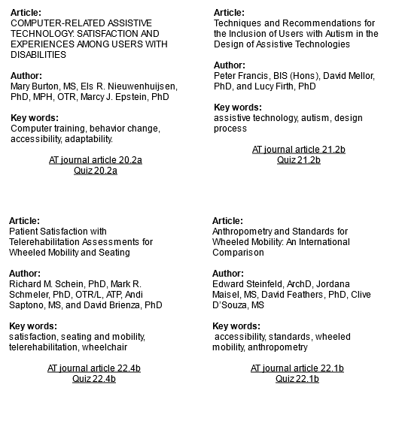
All available and published quizzes will be listed as shown above. The quiz’s title will be shown under the article; the author list under the Author, keywords under keywords.

Landing Page View
No landing page view will be created for this content as the content is primarily displayed in PDFs.

Publishing workflow
Content editors can create the nodes of this content type, but are never able to publish the content. Editors will mark the content as ready to review through which an email will be triggered to the webmaster. The webmaster (administrator) can publish the content or decline the publication with a comment. The webmaster and administrator can always by-pass the publishing workflow.

RSS feed
Not part of any RSS feed.

Navigation Flow, URL Structure and Menu Positions
No part of the Navigation as the content type is only used on views. No URL structure necessary.

Access / Permissions
Anonymous user can access the content.
Webmaster and above can edit / upload new slides.

References to Wireframes

Other Notes
- Phase 2 write back to MemberSuite
- Create quiz with webforms
- Check on current quiz on SSO

Testimonial

At a Glance
A testimonial will be featured throughout the website either on the left hand side or at the bottom of the main content area. It will feature one random testimonial.

Content Fields
- Name [text field*]
- Additional Information [text field]
- Body [body field*]
- Image [image upload]
- Category [vocabulary testimonial category; drop-down]

Block View
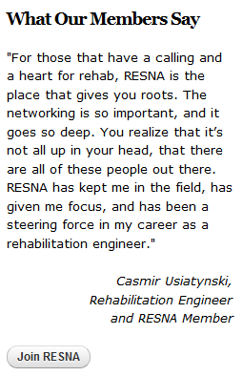

List Views (Grid / List)
The list view will show 5 testimonials. Each testimonial will show the following:
What Our Members Say
{Body 1}
{Name 1}
{Additional Information 1}

{Body 2}
{Name 2}
{Additional Information 2}

Etc.

Landing Page View
No landing page view will be created for this content type as the content is primarily displayed in blocks and views.

Publishing workflow
Content editors can create the nodes of this content type, but are never able to publish the content. Editors will mark the content as ready to review through which an email will be triggered to the webmaster. The webmaster (administrator) can publish the content or decline the publication with a comment. The webmaster and administrator can always by-pass the publishing workflow.

RSS feed
Not part of any RSS feed.

Navigation Flow, URL Structure and Menu Positions
No part of the Navigation. No URL structure necessary.

Access / Permissions
Anonymous user can access the content.
Webmaster and above can edit / upload new slides.

References to Wireframes
N/A.

Other Notes
N/A.

SIG / PSG

At a Glance
This content type is used for the Special Interest Groups (SIGs) and Professional Specialty Groups (PSGs).

Content Fields
The following attributes are available for this content type.
- Title [text field*]
- Category [select box {SIG, PSG}]
- Body [body field*]
- Officers (can be multiple)
  - Title [text field]
  - Name [text field]
  - Email [Email Field]
  - Phone Number [text field]
  - Show phone number [checkbox]
  - MemberSuite Reference [MemberSuite User ID]
- Weight

Block View
A block view simply listing the names will be created for each category [SIG and PSG].

List Views (Grid / List)
N/A.

Landing Page View
The following Layout will be used for this content type:

{Title}
{Officer 1 Title}: {Officer 1 Name}, {Officer 2 Email}*
{Officer 2 Title}: {Officer 2 Name}, {Officer 2 Email}, {Officer Phone Number (if show phone
number is checked}*

{Body}

*If the MemberSuite Reference is available, New Target will pull the information directly from the MemberSuite database. In addition an image to each person will be displayed if the image link is also available in MemberSuite. This way, the users are maintaining their records on their own. If a title changes in MemberSuite, the new title will automatically be pulled from MemberSuite onto the website.

Publishing workflow
Content editors can create the nodes of this content type, but are never able to publish the content. Editors will mark the content as ready to review through which an email will be triggered to the webmaster. The webmaster (administrator) can publish the content or decline the publication with a comment. The webmaster and administrator can always by-pass the publishing workflow.

RSS feed
Not part of any RSS feed.

Navigation Flow, URL Structure and Menu Positions
The pages will live under the following hierarchy:
About → Bylaws → Leadership → Committee → Special Interest Groups
About → Bylaws → Leadership → Committee → Professional Specialty Groups

Depending on the category (SIG or PSG), the content will be pulled on the different section of website.

Access / Permissions
Anonymous user can access the content.
Webmaster and above can edit / upload new slides.

References to Wireframes
N/A.

Other Notes
N/A.

Committee

At a Glance
This content type is used for the different committees.

Content Fields
The following attributes are available for this content type.
- Title [text field*]
- Body [body field*]
- Image [image upload]
- Next Meeting [full text field]
- Officers (can be multiple)
  - Title [text field]
  - Name [text field]
  - Employer [text field]
  - Email [Email Field]
  - Phone Number [text field]
  - Show phone number [checkbox]
- Work Program [full text field]
- ISO Related Activities [full text field]
- Membership information [multi file upload and file description]
- Related Standards [multiple; node reference]
- Category [Committee Type vocabulary]
- Weight

Block View
N/A.

List Views (Grid / List)
- Professional Standards Board & Board of Directors landing pages → MemberSuite
A list view will be created from this content type. It will list all items ordered by the weight. The following Layout will be used for each node in the list view:

{Title}
{Summary}
{Link to node}

Landing Page View
The following Layout will be used for this content type:

{Title}
{File Description}
Officers:
{Officer Title}: {Officer Name}
{Officer Employer}
{Officer Email}
{Officer Phone Number (if show phone number is checked)}
Next Meeting:
{Next Meeting}

{Body}

Work Program:
{Work Program}

ISO Related Activities
{ISO Related Activities}

Publishing workflow
Content editors can create the nodes of this content type, but are never able to publish the content. Editors will mark the content as ready to review through which an email will be triggered to the webmaster. The webmaster (administrator) can publish the content or decline the publication with a comment. The webmaster and administrator can always by-pass the publishing workflow.

RSS feed
Not part of any RSS feed.

Navigation Flow, URL Structure and Menu Positions
No part of the Navigation. No URL structure necessary.

Access / Permissions
Anonymous user can access the content.
Webmaster and above can edit / upload new slides.

References to Wireframes
N/A.

Other Notes
N/A.

Menus
The following menus will be created:
- Main Navigation
  - The main navigation will be used in three placed: The main menu, the left menu on internal pages, and the footer menu.
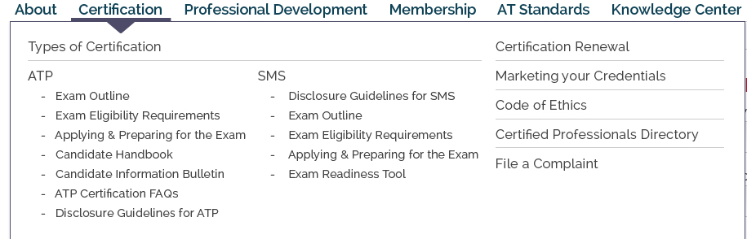
- Utility Navigation
  - The utility navigation can be found in the top right corner next to the social media icons.

- Footer Utility Navigation
  - The footer navigation will be placed at the bottom of the page.

The details (menu items) can be found in the appendix.

Panels Layouts / Landing Pages
In addition to the content type layout and landing page, RESNA will be able to make use of panels throughout the website. To make each landing page as flexible as possible, panels (Drupal Panels module) will be utilized to create the landing pages below.
The following layouts will be setup initially by New Target:
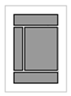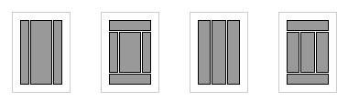
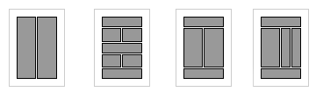
Figure 3.1: Panels Layout

Each column can be filled with different content such as
- Node Reference
- Custom Content
- Views
- Existing content blocks
- Page Elements, e.g.
- Breadcrumbs
- Page title
- Etc.
Each item can be moved around by simply using the drag & drop functionality.

Panels will be primarily be used on the standard pages for which the following layout will be used:

The layout will translate into the following:
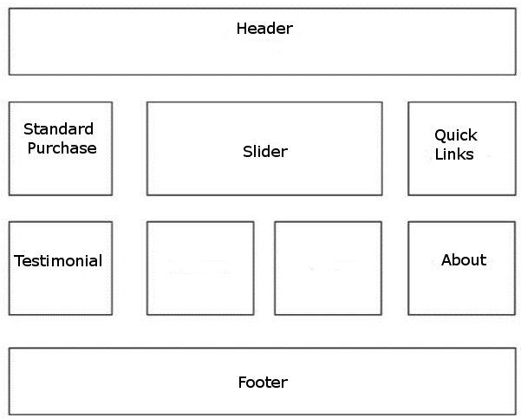

The header and footer section will stay as on the main website template. The content blocks within the page are using node references (e.g. About). Testimonials can be either pulled in by category, or show up as one random testimonial. The empty boxes can be utilized to show case any given attribute from the standards content type. The above view is not limited to what you see, and can be extended with additional content blocks and views as necessary.

Third Party Integration

Overview
The following graphic shows an overview of all systems involved:
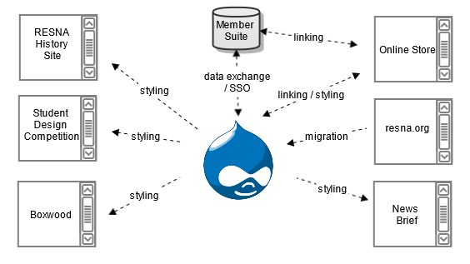
Figure 4.2: Architecture Overview

*The styling of the History Site and Student Design Competition will be excluded from the project as these projects are supported by individuals only.

MemberSuite

Single Sign On
The goal is to connect all third party tools to the CMS in order to create a single login for all ac-counts. Drupal will initiate and terminate all third party tokens if possible:
- When the user logs into the member area of the website, a user session will be created. Necessary tokens or cookies will be created.
- When the user logs out of the website, all active connections to any third party will be terminated. When a user logs out of a third party, the user has to be redirected to /user/logout in order to terminate the session on the Drupal end as well.

The only true SSO available on the website will be the connection to MemberSuite.

The web service for MemberSuite is built on top of the API which can be utilized via web service. Sample PHP code for connecting to the web service and requesting data via web services are available online:
- https://github.com/membersuite/sdk-php/tree/master/APISample/SSOWithWSDL
- https://api.membersuite.com/mex

Login Destination
After the user has been validated through the SSO connection to MemberSuite, the user will be redirected to the user’s Profile page on MemberSuite.

Logout Redirect
After the user logged out of the Drupal, the user will be redirected to the home page. On logout, the user session also needs to be terminated on the MemberSuite end using the web service.

Registration Workflow
All user registration will go through MemberSuite.

Third Party Content
All content except the ATP directory related information will be displayed on MemberSuite.

Look and Feel
MemberSuite will mimic the look and feel of the new website. However, there are a couple of restrictions when it comes to updating the look and feel. Unfortunately, the updates to CSS are out of New Target’s hand.

ATP Directory
The ATP directory is connected to the MemberSuite database. Website visitors can use the following form to query the database:

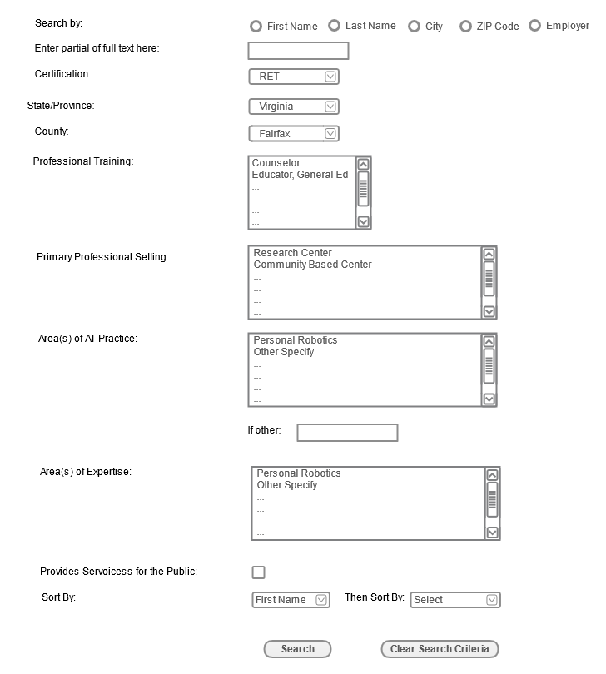
All filtering options for
- Certification
- State / Province
- Country
- Professional Training (multi-select)
- Primary Professional Setting (multi-select)
- Area(s) of AT Practice (multi-select)
should be coming from the database. If MemberSuite does not provide these items, they will be hard-coded into the form. Furthermore, the user will be able to sort the data by
- First Name
- Last Name
- City
- State
- Zip Code
- Employer
- Certification
Any selection leads to an ‘AND’ clause in the database. For instance, a search for a Certification ‘RET’ and a state of ‘Connecticut’ will only results of AT Professionals in Connecticut that have the RET certification. All other AT professionals will be ignored.

Once the user submitted the search, the user will see a list of 20 professionals per page displaying last name, first name, certification, employer, city, state, country, and if the professional is a RESNA member. The first and last name in the result set link to more information:
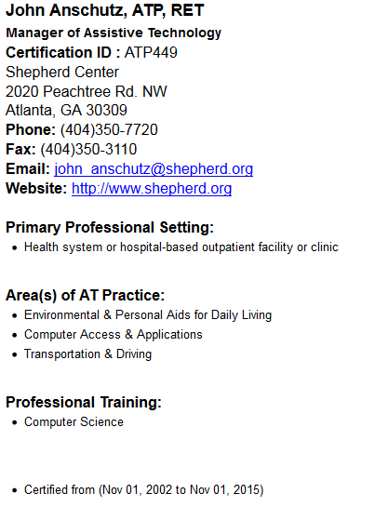
Missing from the above informtion is the ‘is RESNA Member’ indicator, which will be placed at the bottom of the page, as well as the member description available in MemberSuite. If a thumbnail in MemberSuite is available, it will be featured on the top left.

The current form is available online:
http://resna.org/member_directory/individual/index.dot

There is also a quick search available throughout the website:
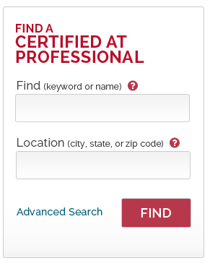
The above form will perform a search on the MemberSuite database with the user input for name and location. If both fields are entered, the query will perform and ‘AND’ search in the database meaning that both attributes have to be met in order to return data.
The user can leave one field empty.
The result set is similar to the one above, however, it will also show the user a link to the advanced search (first screen shot in this section).

MemberSuite has provided the database schema in XSD files. This will allow New Target to identify the tables and columns needed for quering the data.

Member Directory
Similar functionality to the ATP directory, but it should only be available to members only.
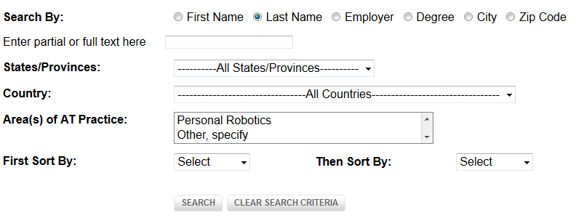
http://resna.org/member_directory/Member/index.dot

The difference to the form above is that the presentation of the results will display degree instead of certification. Furthermore, the member details are following the same layout, but will present different data:

If for instance data for website is not available, the information (website) will not be displayed.

NewsBriefs
The NewsBriefs header (including logo, menu, and social media icons), footer, background color, and some pieces of the text color within the main content block will be updated to match the new design as closely as possible. However, that the update to the look and feel of NewsBriefs is limited, and that the design will not fully match the new look and feel of the website. The overview page can be found here:
http://multibriefs.com/briefs/resna/RESNA091013.php

The subscription page has further limitations. The only changes New Target can undertake are the main logo and the background image. The subscription page can be found here:
http://multibriefs.com/optin.php?resna

RESNA History Website
Since this website has been created by a volunteer, RESNA decided not to update the current Student Design Competition site with a new design.

Student Design Competition
Since this website has been created by a volunteer, RESNA decided not to update the current Student Design Competition site with a new design.

Prometric Sample Quiz
Prometric is a third party service that does not require any login or single sign-on. A simple link to the third party will be created.

AT Journal
In order to link to the AT Journal, a simple TPS Link can be created. The following code can be utilized for this.
<?
$ticketurl='http://www.tandfonline.com/loi/uaty20#.UjiibT-QH3E’;
if (($fp = fopen($ticketurl, 'r')))
{
$content = fread($fp, 1000000);
header("Location:".$content);
}
fclose($fp);
?>

The code has to be executed on the server level. Taylor & Francis Online needs to be contacted to inform them about the IP.
The code will only be triggered for members. If it is a non-member, the user will simply be redirected to Taylor & Francis Online and will only be able to view the freely available content.

SOLR Search
The search will utilize Apache Solr server to index content as well as files and documents on the server. Solr is an open source enterprise search platform from the Apache Lucerne project. Its major features include powerful full-text search, hit highlighting, faceted search, dynamic clustering, database integration, rich document (e.g., Word, PDF) handling, and geospatial search. Solr is highly scalable, providing distributed search and index replication.
We will integrate Apache Solr with Drupal to support basic search as well as advanced search, which will include searching of content type.
The following features are available (but not limited to) with the Apache Solr integration into Drupal:
- Faceted Search
- Drill down by content type, tag, date range, etc.
- More like this (automatically-generated content blocks that show similar nodes)
- Search Pages (multiple search pages optionally with customized search results)
- Range Queries
This allows RESNA to fully customize the following items on the search results page:
- Breadcrumbs
- Retain filters while searching with new keywords
- Theming of search results
- Drilldown into dates by year, month, data, and time
- Faceted Slider
- Filter by Tag Cloud

The following content types will be excluded from the search:
- Slide Show
- Testimonial
- Instructor
- Sponsor

New Target will pre-configure the Solr search for RESNA based on best practices.

Forms and Form Builder Module
New Target will implement a form builder module (Webforms) to allow RESNA to build, add, and edit the forms throughout the website. RESNA will be able to change the email for each of the forms that are creating with the form builder module. The form builder module is for the creation of simple forms that do not require integration with payments processors or third party databases. Therefore RESNA can create new forms at any time for different purposes.

Contact Us
Above the form the following information will be displayed:
RESNA
1700 North Moore Street
Suite 1540
Arlington, VA 22209
PHONE: (703) 524-6686
FAX: (703) 524-6630

To contact RESNA in person, you can email or call the appropriate department, listed below. General inquiries will be responded to within 1-2 business days.

DEPARTMENT EXTENSION E-MAIL
Membership Ext: 310 membership@resna.org
Certification Ext: 314 certification@resna.org
Publications Ext: 310 publications@resna.org
Annual Conference Ext: 305 conference@resna.org
Exhibits Ext: 305 exhibits@resna.org
Assistive Technology Journal Ext: 310 journal@resna.org
RESNA News Ext: 305 resnanews@resna.org
RESNA as a Continuing Education Units Provider Ext: 310 ceu@resna.org
RESNA Catalyst Project Ext: 304 resnaTA@resna.org
Alternative Financing Technical Assistance Project Ext: 309 resnaTA@resna.org
RESNA Webmaster webmaster@resna.org

The general contact us form submissions will be emailed to webmaster@resna.org. A copy of each submission will be kept in Drupal. The following fields are available for the website visitor:
- Name*
- City
- Country
- Organization
- Position
- E-mail*
- Subject*
- E-Mail Body*
- RE-CAPTCHA*

Constant Contact
Constant Contact will be utilized to sign-up for the email newsletter. The following code will be utilized:
<form name="ccoptin" action="http://visitor.r20.constantcontact.com/d.jsp" target="_blank" method="post">
<input type="text" name="ea" size="20">
<input type="submit" name="go" value="GO" class="submit">
<input type="hidden" name="llr" value="lbuuqubab">
<input type="hidden" name="m" value="1101273911339">
<input type="hidden" name="p" value="oi">
</form>

Drupal Forum
This Drupal forum will replace the current listserv. No data needs to be migrated.

Every user should be able to subscribe to a topic / post and will receive a digest once a day. There are two types of forums – an open forum (open to anyone) and a members-only forum (where the member would need to log in to access the forum).

The Open Forum (non-member access) has only one topic:
- AT Forum

The Members-Only Forum has the following topics:
- Accommodations
- Cognition & Sensory Loss
- Communication Technologies and Computer Access
- Consumer Access, Priorities, and Benefits over the Lifespan
- Delivery, Outcomes & Policy
- International
- Wheeled Mobility & Seating
- Educators
- Occupational Therapists
- Physical Therapists
- Engineers & Technologists
- Speech-Language Pathologists/Audiologists
- Suppliers & Manufacturers

The Board Committee Forum has the following topic:
- Board Committee

Topics can be added by members and committee members, but the webmaster has to approve topics before they will be published.

- Access to Forum based on MemberSuite for SIG/PSG/Board (depends on data from MemberSuite)

Content Migration
The only content that will be migrated is from the dotCMS database. New Target will export the most recent data at the beginning of the content migration process to start mapping the content into content types. The data from dotCMS can be export in the CMS Admin section under maintenance or each content type can be exported by itself (Content → Export). The following content types will be mirgated.
- Blog
- Chapter
- Committee_About
- Event
- News Item
- Web Page Content

The following items will be excluded from the migration:
- Tools (only test data, no migration)
- Structure1 (no migration)
- Macro Documentation (only test data, no migration)
- Content for flash banner (only test data, no migration)
- Facility (no data, no migration)
- Comments (only test data, no migration)
- Building (nothing to import)
- Blog Entry (only test data, no migration)
- NewsletterSidebar (no data, no migration)
- Promo (only test data, no migration)
- Slide Image (no data, no migration)
- Slide Show (no data, no migration)
- Sponsor (only test data, no migration)

The website will be migrated with the current information architecture. Once it has been migrated into Drupal, the information architecture will be updated.

During the migration process, a 301 redirect will be created for all migrated pages. Some content that currently resides in content blocks will not receive a 301 redirect as they are technically living on another page or the content might have been placed on multiple pages.

Conference Proceedings will be not be migrated into the CMS, but moved within their current folder structure. No chances to the hierarchy or content will be performed.

301 Redirects
New Target will create 301 redirects for the migrated content, and create any additional redirects as provided by RESNA in one lump sum. Each page will be migrated into the new system including the old URL attribute, which will then in turn be used to the 301 redirects.

Error pages

404 Error
During the content migration process, New Target will implement SEO friendly URLs and add 301 redirects for the migrated content. After the content migration process, there might be pages indexed or bookmarked to the old URLs which might not have a 301 redirect. The user should be informed that the page no longer exists. Besides that, each 404 page will be logged in the CMS and a 301 redirect can be added at a later stage. The following error pages will be created:

Page Not Found
The page you requested was not found. Possible reasons are:
1. an out-of-date bookmark/favorite
2. a search engine that has an out-of-date listing for this site
3. a mistyped address
4. you have no access to this page
5. The requested resource was not found.
6. An error has occurred while processing your request.

Additionally, a search box, a link to the homepage, as well as a link to the sitemap will be presented to the user.

403 Error
Each page that is accessed by a user that is not signed into the website, will redirect the user to the Drupal 403 page (seen in the Appendix) which shows a login form that validates the user against the MemberSuite database, along with explaining the reason why the page was not accessible.

The content for the error message can be fully managed by RESNA.

Wireframe / Design Description

Design

Header

The global header will feature a hidden ‘Skip Navigation’ link above the logo. The logo will link back to the home page.
The utility bar can be fully managed through the utlilty menu further described in the menu section of this document. Social media icons will link as follows:
- Twitter
  - https://twitter.com/resnaorg
- Facebook
  - https://www.facebook.com/RESNAorg
- LinkedIn
  - http://www.linkedin.com/groups?gid=79388&trk=myg_ugrp_ovr
- Google Plus
  - https://plus.google.com/117322942691845852036
Under the social media icons, the search will be permanently visible to all website visitors. If the user enters a search term, the simple search will be triggered. Once the visitor sees the result set, the visitor can further refine the search using the advanced search features.
The main navigation is using the main menu (see complete menu in menu section of this document) and will display level 1, 2, and 3 of the navigation items.

MemberSuite allows to query the data for any items placed in the shopping cart. If any an item has been placed into the shopping car, a cart Icon will be displayed on top of the page.

Footer
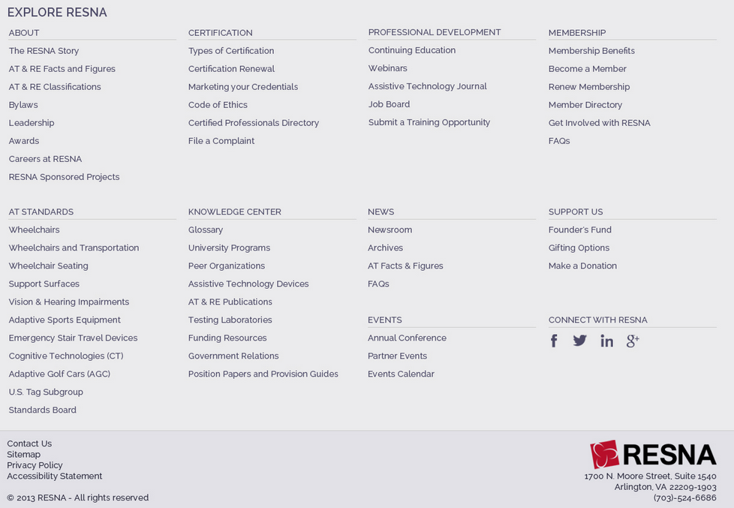

Additional Static Content Blocks










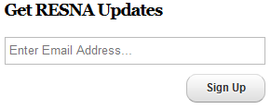

Design

Please refer to http://projects.newtarget.net/resna/ for additional designs.

Responsive Design

Accessibility
Criteria | Department Responsible | URL to assist with implementation
All non-text content that is presented to the user has a text alternative that serves the equivalent purpose | Development | http://www.w3.org/WAI/WCAG20/quickref/#text-equiv
Time-based Media: Provide alternatives for time-based media. | RESNA
The visual presentation of text and images of text has a contrast ratio of at least 4.5:1, except for the following: | Design | http://www.w3.org/WAI/WCAG20/quickref/#visual-audio-contrast
Large Text: Large-scale text and images of large-scale text have a contrast ratio of at least 3:1; | Design
Incidental: Text or images of text that are part of an inactive user interface component, that are pure decoration, that are not visible to anyone, or that are part of a picture that contains significant other visual content, have no contrast requirement.
Logotypes: Text that is part of a logo or brand name has no minimum contrast requirement.
All functionality of the content is operable through a keyboard interface without requiring specific timings for individual keystrokes. | Development | http://www.w3.org/WAI/WCAG20/quickref/#keyboard-operation
Timing is not an essential part of the event or activity presented by the content, except for non-interactive synchronized media and real-time events. | Development | http://www.w3.org/WAI/WCAG20/quickref/#time-limits
Interruptions can be postponed or suppressed by the user, except interruptions involving an emergency. | Development | http://www.w3.org/WAI/WCAG20/quickref/#time-limits
When an authenticated session expires, the user can continue the activity without loss of data after re-authenticating. | Development | http://www.w3.org/WAI/WCAG20/quickref/#time-limits
Web pages do not contain anything that flashes more than three times in any one second period. | Design, Development | http://www.w3.org/WAI/WCAG20/quickref/#seizure
More than one way is available to locate a Web page within a set of Web pages except where the Web Page is the result of, or a step in, a process. | PM, Design, Development | http://www.w3.org/WAI/WCAG20/quickref/#navigation-mechanisms
Headings and labels describe topic or purpose. | RESNA, PM | http://www.w3.org/WAI/WCAG20/quickref/#navigation-mechanisms
Any keyboard operable user interface has a mode of operation where the keyboard focus indicator is visible. | Development | http://www.w3.org/WAI/WCAG20/quickref/#navigation-mechanisms
A mechanism is available to allow the purpose of each link to be identified from link text alone, except where the purpose of the link would be ambiguous to users in general. | RESNA
Section headings are used to organize the content. | RESNA
The human language of each passage or phrase in the content can be programmatically determined except for proper names, technical terms, words of indeterminate language, and words or phrases that have become part of the vernacular of the immediately surrounding text. | Development | http://www.w3.org/WAI/WCAG20/quickref/#meaning
A mechanism is available for identifying specific definitions of words or phrases used in an unusual or restricted way, including idioms and jargon. | RESNA, PM, Development | http://www.w3.org/WAI/WCAG20/quickref/#meaning
A mechanism for identifying the expanded form or meaning of abbreviations is available. | RESNA, PM, Development | http://www.w3.org/WAI/WCAG20/quickref/#meaning
When text requires reading ability more advanced than the lower secondary education level after removal of proper names and titles, supplemental content, or a version that does not require reading ability more advanced than the lower secondary education level, is available. | RESNA, PM, Development | http://www.w3.org/WAI/WCAG20/quickref/#meaning
A mechanism is available for identifying specific pronunciation of words where meaning of the words, in context, is ambiguous without knowing the pronunciation. | RESNA, PM, Development | http://www.w3.org/WAI/WCAG20/quickref/#meaning
Navigational mechanisms that are repeated on multiple Web pages within a set of Web pages occur in the same relative order each time they are repeated, unless a change is initiated by the user. | Design | http://www.w3.org/WAI/WCAG20/quickref/#consistent-behavior
Components that have the same functionality within a set of Web pages are identified consistently. | Development | http://www.w3.org/WAI/WCAG20/quickref/#consistent-behavior
Changes of context are initiated only by user request or a mechanism is available to turn off such changes. | Development | http://www.w3.org/WAI/WCAG20/quickref/#consistent-behavior
If an input error is automatically detected and suggestions for correction are known, then the suggestions are provided to the user, unless it would jeopardize the security or purpose of the content. | PM, Development | http://www.w3.org/WAI/WCAG20/quickref/#minimize-error
For Web pages that require the user to submit information, at least one of the following is true: (Level AAA) | Development | http://www.w3.org/WAI/WCAG20/quickref/#minimize-error
1. Reversible: Submissions are reversible. | Development | http://www.w3.org/WAI/WCAG20/quickref/#minimize-error
2. Checked: Data entered by the user is checked for input errors and the user is provided an opportunity to correct them. | Development | http://www.w3.org/WAI/WCAG20/quickref/#minimize-error
3. Confirmed: A mechanism is available for reviewing, confirming, and correcting information before finalizing the submission. | Development | http://www.w3.org/WAI/WCAG20/quickref/#minimize-error
Context-sensitive help is available. | PM, RESNA | http://www.w3.org/WAI/WCAG20/quickref/#minimize-error

Appendix

Sitemaps

Header Utility Navigation
- Login
- Online Store
- Contact Us
- Facebook (https://www.facebook.com/RESNAorg)
- Twitter (https://twitter.com/resnaorg)
- LinkedIn (http://www.linkedin.com/groups?gid=79388&trk=myg_ugrp_ovr)
- Google Plus (https://plus.google.com/117322942691845852036)

Main Navigation
About
- A Message from the President
- History
- AT & RE Facts and Figures
- AT & RE Classifications
- Bylaws
  - Leadership
    - Board of Directors
    - Executive Director
    - Committees
      - Assistive Technology Standards
      - Awards
      - Bylaws
      - Education
      - Ethics
      - Finance
      - Government Affairs (GAC)
      - Long-Range Planning
      - Meetings
      - Membership
      - Nominating
      - Professional Specialty Groups (PSGs)
      - Professional Standards Board (PSB)
      - Research
      - Special Interest Groups (SIGs)
    - RESNA Development Board
- Awards
  - Nomination Criteria
  - Award Recipients
- Careers at RESNA

Get Certified
- Types of Certifications
- ATP
  - Exam Outline
  - Exam Eligibility Requirements
  - Applying and Preparing for the Exam
  - Candidate Information Bulletin
  - Candidate Handbook
  - ATP Certification FAQs
  - Disclosure Guidelines for ATP
- SMS
  - Disclosure Guidelines for SMS
  - Exam Outline
  - Exam Eligibility Requirements
  - Applying and Preparing for the Exam
  - Exam Readiness Tool
- Certification Renewal
- Marketing Your Credentials
- Code of Ethics
- Certified Professionals Directory
- File a Complaint

Professional Development
- Continuing Education
  - Courses
  - Accessible Technology Action Center
  - RESNA Catalyst Project
  - Quizzes
  - Assistive Technology Services Training
  - Assistive Technology Device Training
- Webinars
- Assistive Technology Journal
  - Editorial Board
  - Submission Guidelines
  - Submit an Article
- Job Board
- Submit Training Opportunity
- Get Involved with RESNA
  - ListServs (to be replaced with Drupal form)
  - Special Interest Groups
  - Professional Specialty Groups

Membership
- Membership Benefits
- Become a Member
  - Annual Individual
  - Non-Profit Organization Membership
  - For-Profit Organization Membership
  - Student Membership
  - Trial Membership
- Renew Membership
- Member Directory
- FAQs

AT Standards
- Wheelchairs (including Scooters)
- Wheelchairs and Transportation
- Wheelchair Seating
- Support Surfaces
- Vision & Hearing Impairments
- Adaptive Sports Equipment
- Emergency Stair Travel Devices for Individuals with Disabilities
- Cognitive Technologies (CT)
- Adaptive Golf Cars (AGC)
- U.S. TAG Subgroup to ISO TC 173/SC 2 – Classification and Terminology
- Standards Board

Knowledge Center
- Glossary
- University Programs
- Peer Organizations
- Assistive Technology Devices
- AT & RE Publications
- Testing Laboratories
- Government Relations
  - Policies and Laws
  - Government Funded Research
  - Government Agencies involving AT and RE
- Funding Resources
- Position Papers and Provision Guides

News and Events
- News Archives
- Annual Meeting
  - Call for Papers
  - Registration
  - Location
  - Exhibitors
  - Students
    - Student Scientific Paper Competition
    - Student Design Competition
  - Annual Meeting Archives
    - Program
      - Conference Schedule
      - Workshop Descriptions
      - Plenary Sessions and Speakers
      - Instructional Courses
      - Workshop Handouts
    - Exhibitors Listing
    - Sponsors
  - Annual Meeting Proceedings
  - Conference Evaluation and CEU Credits
- Events Calendar

Support RESNA
- Founder’s Fund
- Founders
- Gifting Options
- Make a Donation

Note: removed Conferences and meetings from the Resources area. A lot of these were just links to organizations. This information should be added to the events content type.
Note: removed Conference News from the Conferences landing page. This news should be rolled into the News and Events section
Note: removed the Committee meetings link from AT Standards, as this information can go into the event calendar

Footer Utility Navigation
- Contact Us
- Sitemap
- Privacy Policy
- Accessibility Statement

